

University of Ghana

College of Basic and Applied Sciences

School of Engineering Sciences

1st Semester (2020/2021)

CPEN 205: Introduction to Software Engineering

Semester Project

Jessica Awuradjoa Asamoah -10851366

Table of Contents

NEW CREATION CHURCH WEB APPLICATION AND MOBILE APPLICATION 2

1.0 Problem Statement 2

2.0 Requirements 2

2.1 User Requirements 2

2.2 Functional Requirements 2

2.3 Non-Functional Requirements 2

3.0 SOFTWARE PROCESS 3

4.0 SOFTWARE MODELING 3

4.1 USE-CASE DIAGRAM 3

4.2 FLOW DIAGRAM 4

5.0 SOFTWARE SYSTEM ARCHITECTURE 4

6.0 DESIGN AND IMPLEMENTATION 5

7.0 TESTING 5

8.0 SOFTWARE PROJECT MANAGEMENT 5

9.0 CONCLUSION 5

# 

# NEW CREATION CHURCH WEB APPLICATION AND MOBILE APPLICATION

# 1.0 Problem Statement

After being hit by the pandemic, churches have been forced to close down. People don’t have access to weekly sermons to build up their faith causing a disconnection with the word of God.

# 2.0 Requirements

## 2.1 User Requirements

1. To access the features of the application, the user needs to create an account.
2. The user can access weekly sermon videos.
3. The user can find a church branch closest to them.
4. The user can access video materials for kids.

## 2.2 Functional Requirements

1. The system should allow users to register for the church records.
2. The system must store the user’s information in a user-friendly and secure environment.
3. The system should allow the user to access weekly videos.
4. The system should display the various church branch locations.

## 2.3 Non-Functional Requirements

1. The system should store the details given by the user in an SQL database.
2. The system must have the passwords encrypted.
3. The system should ensure that the user fills in the all the fields required.
4. The system should make sure that there is no duplication of emails and usernames.

# 3.0 SOFTWARE PROCESS

The agile method was used to develop this software. This method was adapted because it enabled us to cope with continuous change.

# 4.0 SOFTWARE MODELING

## 4.1 USE-CASE DIAGRAM

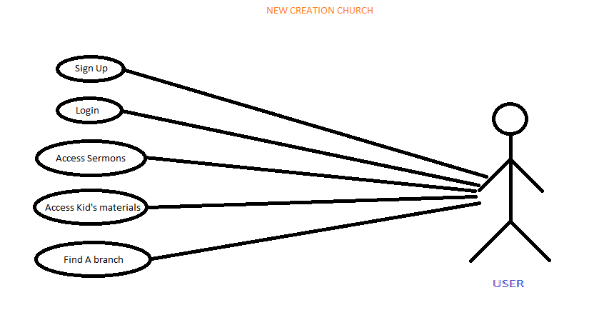

## 

## 4.2 FLOW DIAGRAM

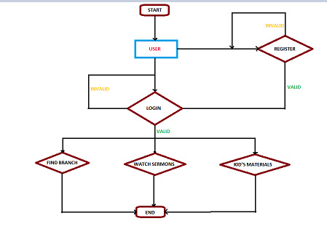

## 5.0 SOFTWARE SYSTEM ARCHITECTURE

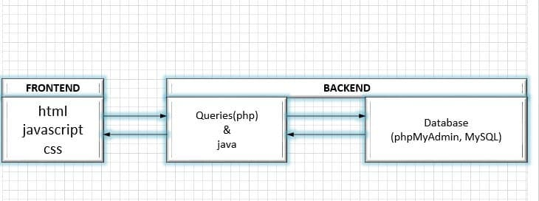

## 6.0 DESIGN AND IMPLEMENTATION

These systems were designed using a structured object-oriented design process.

## 7.0 TESTING

Testing is carried out on the Web Application and the Mobile Applications using fake user details. Any bug or error that occurs was checked and fixed. Both applications run smoothly.

## 8.0 SOFTWARE PROJECT MANAGEMENT

Planning of this project took two to three weeks. During planning sessions all hands were on deck. Scheduled meetings and presentations were always held at the appropriate with no postponement taking place. The cost of creating these software systems was average.

## 9.0 CONCLUSION

To conclude, both systems will be used as web application and an android application after testing. The New Creation Church team will be able to use both web application and android application to provide services to members so they are not left out in their faith in this pandemic.